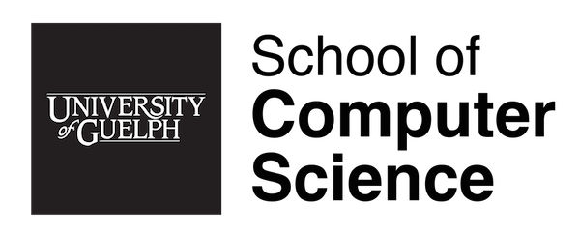

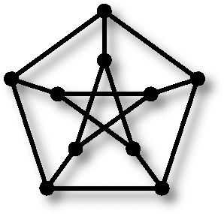
Computationally Speaking
Seminar Series

Title: How I Created the Turing Machine and Won the War
Speaker: Alan Turing
Where: Reynolds 1101
When: Tuesday March 5th 2019, 2:30 – 3:30pm
Abstract: Lorem ipsum dolor sit amet, consectetur adipiscing elit, sed do eiusmod tempor incididunt ut labore et dolore magna aliqua. Ut enim ad minim veniam, quis nostrud exercitation ullamco laboris nisi ut aliquip ex ea commodo consequat. Duis aute irure dolor in reprehenderit in voluptate velit esse cillum dolore eu fugiat nulla pariatur. Excepteur sint occaecat cupidatat non proident, sunt in culpa qui officia deserunt mollit anim id est laborum.
Lorem ipsum dolor sit amet, consectetur adipiscing elit, sed do eiusmod tempor incididunt ut labore et dolore magna aliqua. Ut enim ad minim veniam, quis nostrud exercitation ullamco laboris nisi ut aliquip ex ea commodo consequat. Duis aute irure dolor in reprehenderit in voluptate velit esse cillum dolore eu fugiat nulla pariatur. Excepteur sint occaecat cupidatat non proident, sunt in culpa qui officia deserunt mollit anim id est laborum.

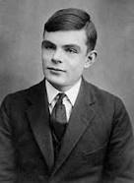
About the Speaker: Alan was an English mathematician, computer scientist, logician, cryptanalyst and philosopher. He was highly influential in the development of theoretical computer science, providing formalization of the concepts of algorithm and computation with the Turing machine, which can be considered a model of a general purpose computer. Turing is widely considered to be the father of theoretical computer science and artificial intelligence.

